BSc in Reproductive & Developmental Sciences & BSc in Surgery and Anaesthesia Project Outline 2011-2012

Project Title: The effect of the head centre of rotation (3D CT measured) on wear of the head-stem junction of retrieved metal and metal (MOM) hip replacements

Academic Supervisor: Alister Hart, Clinical Senior Lecturer & Consultant Orthopaedic Surgeon
Division: Surgery & Cancer
Section: Musculoskeletal Surgery
Co-supervisor: Mr Johann Henckel, Clinical Fellow and SpR in Orthopaedic Surgery

Who will be responsible for day-to-day supervision?
Mr Johann Henckel, Clinical Fellow and SpR in Orthopaedic Surgery

Contact Details of Person whom Medical Student should contact for further details:
Name: Alister Hart Email: a.hart@imperial.ac.uk Tel: 02033117332

Group’s Research Interest
In 2008 Alister Hart and John Skinner (UCL) set up the London Implant Retrieval Centre (LIRC), based at Imperial College London. The LIRC has the largest collection of failed MOM hip implants in the world and has the largest database of clinical and imaging data from these types of patients. We have had 17 papers accepted for publication in the first 9 months of 2011.
(http://www1.imperial.ac.uk/surgeryandcancer/divisionofsurgery/clinical_themes/musculo/retrieval/)

This is a Lab project (clinical translational research).

Suitable project for: Obstetrics & Gynaecology Yes No
Surgery and Anaesthesia Yes No

Background to Project:

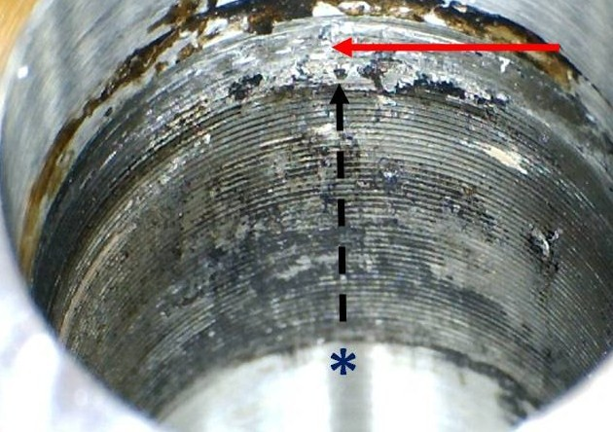
1 million patients worldwide received a metal-on-metal (MOM) hip replacement in the last 15 years. Many types of MOM hips are designed to be used as either resurfacing (involving capping of the femoral head) or modular (involving conventional femoral stem and head components with a head-stem modular junction) hip implants. Recent evidence showed that the five year failure rates were higher for modular designs when compared to resurfacing designs: ASR XL 50%; modular BHR 15%; and modular Durom 15%.

The high failure rates have been attributed to wear of the head-neck junction (see right). The wear of this junction will be a result of patient, surgical positioning and implant design factors but there are no studies that have quantified these.

One of the main surgical positioning factors will be the position of the femoral head centre but this is not straightforward to measure unless using 3D CT (see right). We have the data and expertise to achieve this.

Research Question: What is the effect of the head size, position and centre of rotation on wear at the head-stem junction in metal and metal (MOM) total hip replacement?

Hypothesis Student will Investigate: Hip centre of rotation (head size & neck length) and position has no effect on the wear at the taper of MOM hip replacement.

Methods/Techniques Student will use:

- Measurement of the size of the femoral head, position, centre of rotation and offset (vertical & horizontal) using state of the art 3D CT imaging software.
- Analysis of wear and corrosion at the head stem junction.

Proposed scheme of analysis:

Week 1: Literature search on the background work to this subject.

Week 2 & 3: Training in use of the 3DCTanalysis software.

Week 4 - 8: Measurements of CT datasets of human subjects.

Week 5 – 9: Statistical analysis of measurements

Week 8: collect any incomplete data

Weeks 9: Analysis of the results.

Weeks 10-12: Writing up.

Summer – Write paper

Will the research involve work done under the Animals (Scientific Procedures) 1986 Act? No

Will the research involve the use of genetically modified tissue? No

Will the project involve work on human subjects, human tissue or access to confidential patient information? Yes

If YES

has ethical approval been obtained: Yes

Date approval was granted: 2009

IC REC or IRAS REC number: 07/Q0401/25

Note: Approval for any of the above MUST be in place before the student begins the project.
A risk assessment form will be required.
Project Payment: F account

If you have an F account please give full account code: WSSU.F36741.169507

